DofE Guide - Completing Assessor Reports Online

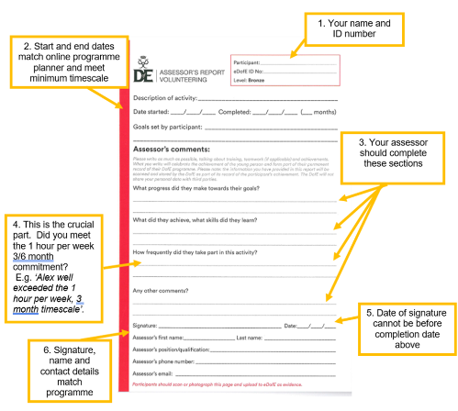
Many of you will have now completed the time commitment for the physical, volunteering and skills sections of your award. The DofE ‘temporary changes’ have increased the options available meaning all should be able to complete in the current climate. Once you have completed your hours and logged evidence the final step to complete the section is to upload a report written up by your Assessor. There are two options for this, the paper copy you received in the post (see below) or an electronic report. This document explains how to request an electronic report.
Timescales – minimum commitment
Bronze – 6/3/3 - 6 months @ 1 hour per week = 26 hours
- 3 months @ 1 hour per week = 13 hours
Silver – 6/6/3 - 6 months @ 1 hour per week = 26 hours
- 3 months @ 1 hour per week = 13 hours
Gold – 12/12/6 – 12 months @ hour per week = 52 hours
- 6 months @ 1 hour per week = 26 hours
Direct entrants do a little longer.
These hours are currently allowed to be in larger blocks of time. For example, 4 hours at a time.
Why an online report?
You may be worried that you can’t get things signed off because of the current restrictions in place. It may well be simpler to email your assessor asking if they might kindly complete your assessor report online. Please see below a template email I have created for you to use to collect your assessor reports.

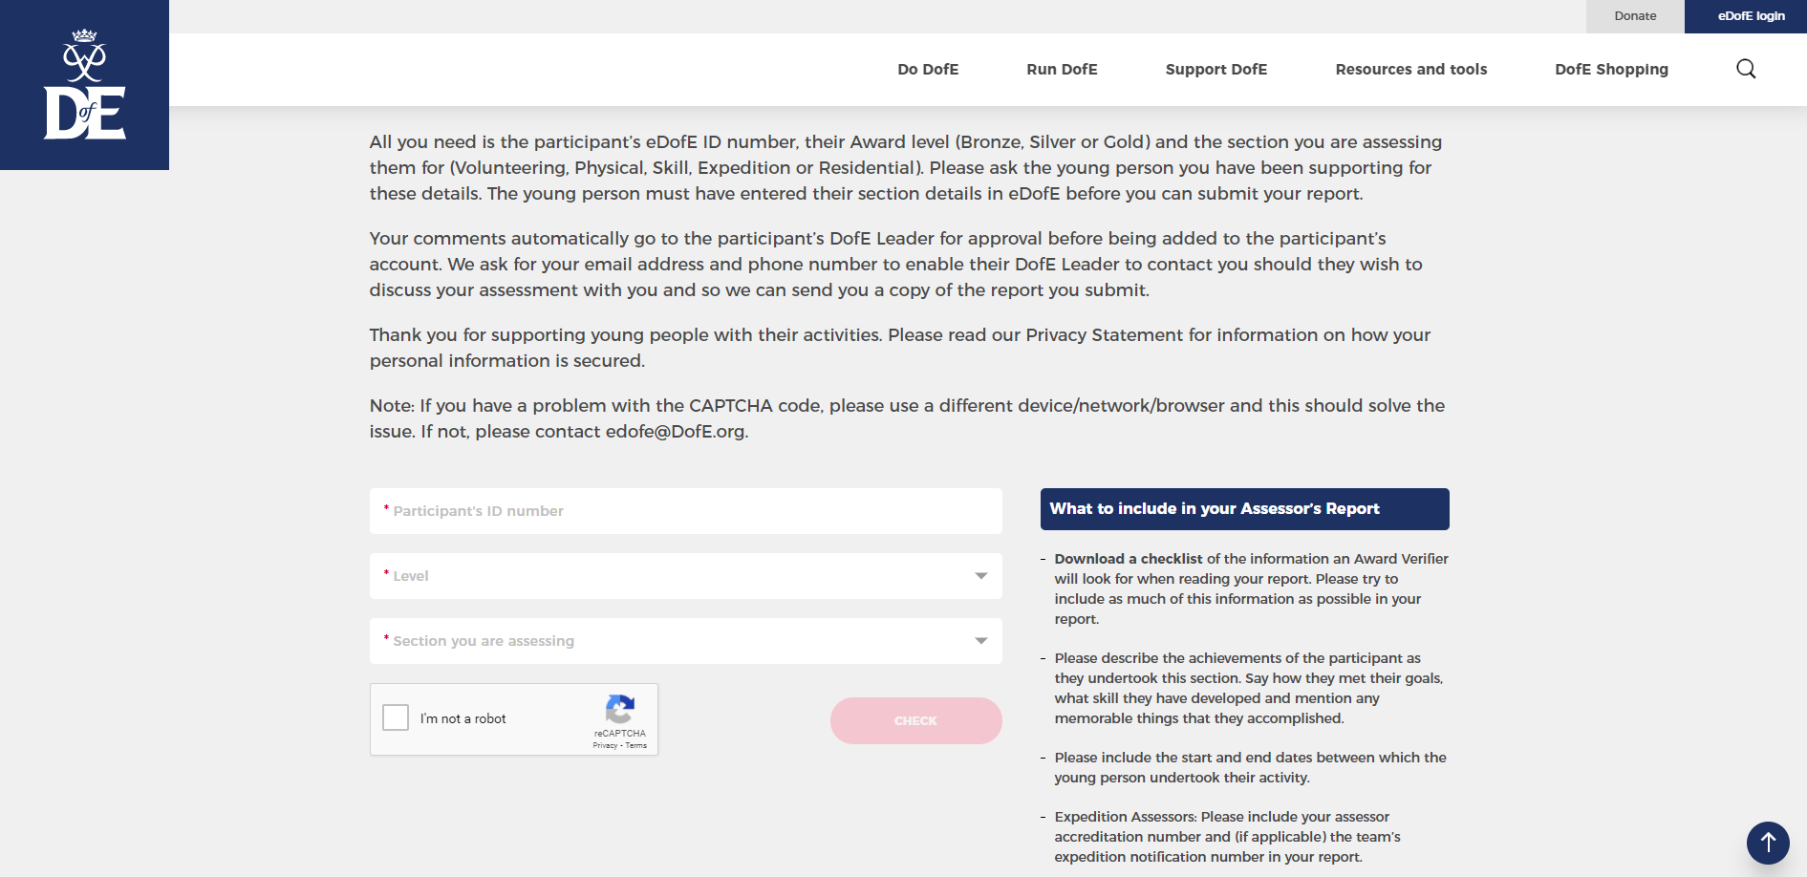

A useful template
(please delete and edit as appropriate)

Dear (Mr Bower)

Earlier in the year you kindly agreed to be my Assessor for my (Bronze/Silver/Gold) Duke of Edinburgh’s Award (physical/volunteering/skill) section. I have now completed the required time commitment and would be very grateful if you could please spare some time complete an online assessor report?

The report can be accessed via this link: https://www.dofe.org/assessor/

My details are as follows:
Participant ID number: (??????????????)
WMB note for participants - you can find this on the sticker on your DofE folder or in the top left corner on your eDofE account.
Level: (Bronze/Silver/Gold)
Section: (physical/volunteering/skill)

There is some guidance on the link on how the report can be filled out, plus some examples. I have (exceeded/met) the time commitment (13/26) hours for this (3/6) month section. Please could you make a statement on the report that I have ‘met the time commitment required for this section’?

I have met my goal and really enjoyed taking part in this activity. My highlight was (…). Thank you for being my assessor and taking the time to complete this form. If you have any questions, please don’t hesitate to ask me.

Best wishes
(Your name)
---------------------------------------------------------------------------------------------------------------------------------------
What’s next?

Once your assessor has completed the report it will be sent straight to your DofE leader: Mr Bower or Mr Robertson and they will approve or query. Remember they’ll be checking the comments carefully to confirm you have worked well and met the time commitment.

You should also upload your activity log, photos or certificates as other evidence. Following this they can approve your section! You should check your eDofE account to see whether it says you’re complete.

I hope you found this information useful. With the expedition dates in place now is the time to submit your reports on eDofE to complete the volunteering, physical and skills sections. The DofE are even offering an additional ‘Certificate of Achievement’ for those who complete these elements.

Good luck
WM Bower Update 05/05/21

